MICE ecosystem model
Deliverable Number: 3.4

Date 30.10.2026 | Final Version
Contributors: Kostantina Michailidou, Athanassios Tsikliras, Patrycja Antosz
Visibility: Public

Document information

Grant Agreement | 101157456
Project Acronym | SURIMI
Project Title | Integration of innovative and reliable socio-ecological models and user-driven solutions into the Digital Twin Ocean, to facilitate what-if scenarios and decision support, under a co-creation approach.
Deliverable Number | D3.4
Work Package Number | WP3
Deliverable Title | MICE ecosystem model: Ready to use, open source, ecological model of medium complexity, deposited in a public repository and accompanied by technical documentation including (1) model purpose, (2) process overview and scheduling diagram(s), comprehensive descriptions of (3) inputs and (4) outputs.
Lead Partner | EII
Authors | Kostantina Michailidou (AUTH), Athanassios Tsikliras (AUTH), Patrycja Antosz (NORCE)
Due Date | 31-10-2026
Submission Date | 3-10-2026
Dissemination Level | Public
Type of Deliverable | Other

Version | Summary of Changes
Version 0 | Initial draft (Kostantina Michailidou)
Version 1 | Addition of figures
Final Version | Inclusion of reviewer suggestions

SUMMARY
This deliverable presents the Model of Intermediate Complexity for Ecosystem assessments (MICE) provided by SURIMI under working package WP3, together with other socio-ecological models, for integration into the European Digital Twin of the Ocean (EU DTO) in WP4. The MICE model is part of the ecological modelling layer of SURIMI, and it presents a lower level of model complexity, compared to the complex ecosystem models developed under the Ecopath with Ecosim (EwE) approach.
Implementations of the EwE model represent entire ecosystems and capture a wide range of ecological processes in great detail. This level of detail can make the models difficult to interpret or result in high data and computational power requirements. On the contrary, the intermediate complexity of the MICE model can balance the representation of key ecological processes and the amount of required information or computational power. By retaining the essential interactions and information needed to address specific research questions, the MICE model can be adaptable to different ecosystems and data-limited situations and can also be transformed into model structures that are easier to understand and manipulate under different research or management scenarios.
This report describes the conceptual framework, modelling approach and development procedure of the MICE model, that was based on an existing complex EwE model of the Aegean Sea, in eastern Mediterranean Sea. It includes the process of applying species aggregation to gradually reduce model complexity and create a series of aggregated ecosystem models with different levels of complexity. The performance of these models was evaluated based on different criteria, using a set of established and commonly used ecological indicators that are produced as EwE model output. The indicators used were Total System Throughput (TST), ascendency, relative ascendency (% ascendency), relative overhead (% overhead), relative redundancy (% redundancy), Finn’s Cycling Index (FCI), Shannon index, Primary Production Required to sustain fisheries to Total Primary Production (PPR/TotPP), System Omnivory Index (SOI), mean Trophic Level of the catch (mTLc), Marine Trophic Index (MTI) and Trophic Level of the community (TLco).
The performance criteria concerned the magnitude of changes in the indicator values, between the successive aggregation levels or compared to the values of the original ecosystem model. The uncertainty of the original model input data was also incorporated in one of the criteria. Based on the performance criteria, an evaluation procedure was applied to identify the MICE model, as a balance point between complexity and performance. The developed MICE model will be incorporated into the EU DTO, together with the rest of the socio-ecological models, to increase the interoperability of SURIMI modelling framework and provide the opportunity of exploring various scenarios and analyzing ecosystem dynamics at a lower level of complexity.
CONTENTS
Document information 1
SUMMARY 2
1. MODEL PURPOSE 4
2. PROCESS OVERVIEW AND SCHEDULING DIAGRAMS 5
2.1. MATHEMATICAL FRAMEWORK OF MICE 5
2.1.1. EwE MODELLING APPROACH 5
2.1.2. DEVELOPMENT OF AGGREGATED MODELS 6
2.2. PERFOMANCE EVALUATION FRAMEWORK OF AGGREGATED MODELS 10
2.2.1. ECOLOGICAL INDICATORS USED FOR SPECIES AGGREGATION IMPACT 10
2.2.2. PERFORMANCE EVALUATION CRITERIA 11
2.3.1. INDICATOR VALUES 12
2.3.2. PERFORMANCE EVALUATION 15
2.3.3. MICE MODEL SELECTION 17
2.3. MICE EXECUTION WITHIN THE SURIMI MODELLING WORKFLOW 17
3. INPUTS 19
4. OUTPUTS 19
5. REFERENCES 21

1. MODEL PURPOSE
Models of Intermediate Complexity for Ecosystem assessments (MICE) can offer a balanced approach in order to understand ecological systems, as they are placed between single-species and whole-of-ecosystem models, regarding their complexity in the number of model components (e.g., functional groups or species) or the processes represented in the model (Plagányi et al. 2014). Species aggregation introduces a way to simplify model structure but can also influence the values of ecological indicators, or the performance and predictions of an ecosystem model (Johnson et al. 2009, Giricheva 2015). Species aggregation concerns both the level of aggregation (number of functional groups (FG) and the type of aggregation (how the FGs are grouped) (Johnson et al. 2009). When too much complexity is applied, excessive uncertainty can be introduced, whereas when there is too little detail, system dynamics might not be represented realistically (Fulton et al. 2003). Therefore, the sensitivity of model results can be tested through different aggregation types, resulting in a “sweet spot” between model complexity and performance.
This “sweet spot” can be considered a MICE approach, representing the simplest model structure that produces results comparable to those of the full-complexity model. Consequently, it constitutes a model that is easier to comprehend and manipulate under management scenarios, and that can also be useful in data-limited situations, as it requires less complexity and data (Plagányi et al. 2014). These are really important traits, especially for the inclusion of this model to the toolbox of the user-friendly interface provided by SURIMI within the DTO infrastructure.
SURIMI aims to integrate socio-ecological what-if simulation models into the Digital Twin Ocean (DTO), which serves as a realistic simulation of the world’s oceans. Within WP3, which is designed to develop the socio-ecological and management strategy evaluation (MSE) models, the ecological layer of model building in Task T3.2 consists of two ecosystem models of opposite complexity: a food web model of intermediate complexity (MICE) (deliverable D3.4), and a fully parameterized spatio-temporal Ecopath with Ecosim (EwE) model (deliverable D3.5). Taking into account a wide range of model complexity will contribute to validate the interoperability of the models, as well as to ensure that this approach can be used to address a variety of marine policy questions.

2. PROCESS OVERVIEW AND SCHEDULING DIAGRAMS
The intermediate level of complexity in the MICE model makes it capable of capturing the ecological interactions needed to investigate specific research questions, while simplifying complex ecological processes that may be difficult to understand. The framework of the development and selection of the MICE model consisted of gradually reducing the complexity of an existing EwE model of the Aegean Sea (Keramidas et al. 2022). EwE’s complexity was reduced by a stepwise aggregation of FGs, from 44 to 10 in the final aggregation level, through four different aggregation approaches and seven aggregation levels in each approach. The main concept was to evaluate several ecological indicator values based on different model performance criteria, to result in a MICE model that will still produce similar results to those of the high complexity model. The mathematical framework of the models, the estimation procedure of the performance criteria, and the selection process of the MICE model are described in the following sections.

2.1. MATHEMATICAL FRAMEWORK OF MICE

2.1.1. EwE MODELLING APPROACH
The EwE software is an ecosystem modelling tool used to represent the trophic structure and dynamics of an ecosystem (Christensen & Walters 2024). The basic module of EwE is Ecopath, which is a static mass-balance model describing the trophic structure of the ecosystem and its links. Based on Ecopath, temporal (Ecosim) and spatio-temporal (Ecospace) dynamic models can be developed. Model components are represented in FGs of single or multiple species that usually share ecological, biological, taxonomical, habitat or trophic similarities. These FGs represent low to high trophic levels, covering the whole trophic spectrum of the ecosystem. Fisheries are also accounted for through landings and discards of different fleets/fishing gears. Ecopath is parameterized based on two master equations that describe the production and the energy balance for each FG $i$in the system (Christensen & Walters 2024):
$P_{i}= {M2}_{i} · B_{i}+ C_{i}+ {BA}_{i}+ E_{i}+ {M0}_{i} · B_{i}$
$Q_{i}= P_{i}+ R_{i}+ U_{i}$
where $P_{i}$ is total production rate (t km⁻² year⁻¹), ${M2}_{i}$ is predation mortality rate (year⁻¹), $B_{i}$ is biomass (t km⁻²), $C_{i}$ is total fisheries catch (t km⁻² year⁻¹), ${BA}_{i}$ is biomass accumulation rate (t km⁻² year⁻¹), $E_{i}$ is net migration rate (t km⁻² year⁻¹), ${M0}_{i}$ is other mortality rate (year⁻¹), $Q_{i}$ is total consumption rate (t km⁻² year⁻¹), $R_{i}$ is respiration and $U_{i}$ represents unassimilated consumption.
Data of biomass (t km⁻²), production/biomass ratio (P/B, year⁻¹) and consumption/biomass ratio (Q/B, year⁻¹) can be provided for the parameter of ecotrophic efficiency (EE) to be estimated for each FG by the model. The diet composition, expressing the proportion of each prey in the diet of each predator, has to be provided as input data, along with the fisheries landings and discards for each FG.
Through Ecosim, temporal simulations can be conducted to investigate how ecosystem structure and functioning will change under different environmental and fishing disturbances or management scenarios (Christensen & Walters 2024). Ecosim consists of biomass dynamics expressed through a series of coupled differential equations of the form:
$$\frac{dB_{i}}{dt}=g_{i} \sum_{i=1}^{n}{Q_{ij}}-\sum_{j=1}^{n}{Q_{ji}}+ I_{i}-\left(F_{i}+ e_{i}+ {M0}_{i}\right) B_{i}$$
where $\frac{dB_{i}}{dt}$ represents the growth rate during time interval $dt$ of group $i$ in terms of its biomass $B_{i}$, $g_{i}$ is its net growth efficiency (production/consumption ratio), $Q_{ij}$ represents consumption by group $i$, $Q_{ji}$ represents predation by group $j$ on group $i$, $I_{i}$ is immigration rate, $F_{i}$is fishing mortality rate and $e_{i}$ is emigration rate. Trophic interactions can occur following the “foraging arena” theory, according to which there are vulnerable and invulnerable components of $B_{i}$’s. The “foraging arenas” where vulnerable prey is available, can be restricted by temporal and spatial constraints in prey and predator activity (Ahrens et al. 2012).

2.1.2. DEVELOPMENT OF AGGREGATED MODELS
The aggregated models that were evaluated to result in a MICE model were developed based on an already existing Ecopath model of the Aegean Sea (Keramidas et al. 2022). This model consists of 44 FGs covering the trophic spectrum of the area, and of four fishing fleets (Figure 1), operating both in Greek and Turkish waters. Species were aggregated based on biological, ecological and taxonomic characteristics, as well as trophic and habitat preferences (Keramidas et al. 2022). However, species considered commercially or ecologically important, were treated as single-species FGs. The Ecopath model represents an annual average of the ecosystem state between 2003-2006 (Keramidas et al. 2022), while the Ecosim model has been fitted to data of observed biomass and catch for the period between 2006-2021 (Keramidas et al. 2024).
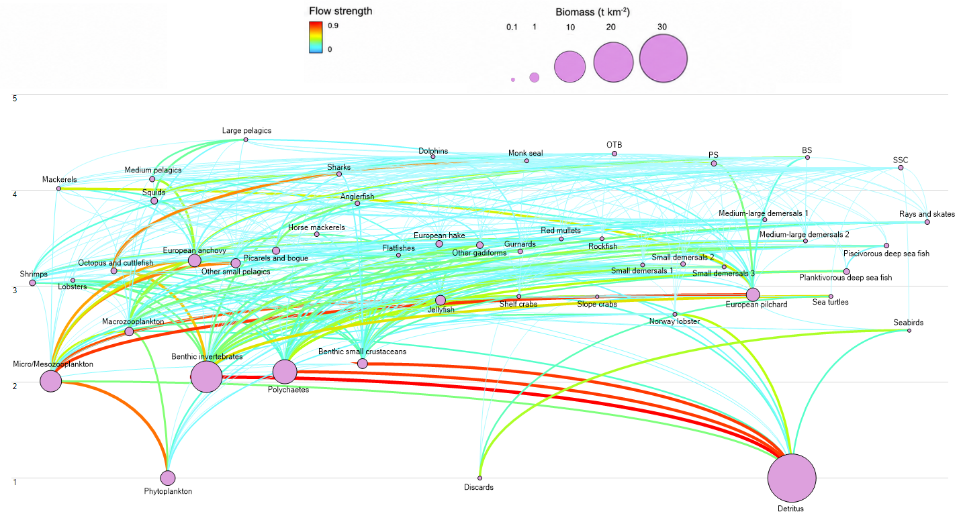
Figure 1. Trophic flow diagram depicting the 44 functional groups (FGs) and 4 fishing fleets (bottom trawlers-OTB, purse seiners-PS, beach seiners-BS, small-scale coastal vessels-SSC) of the original Ecopath model of the Aegean Sea. Trophic levels are given on the left. Adapted from Keramidas et al. (2022).

Four different aggregation approaches were applied to reduce model complexity, through seven different aggregation levels in each one (Figure 2). The models developed in the last aggregation level consisted of the same FGs and species in each FG, to investigate if the alternative approaches would produce different results in the final aggregation level.
The first aggregation approach, trophic level (TL), included a hierarchical aggregation procedure, in which the TL values of the FGs were used to prioritize aggregations both within the lower and the upper ends of the trophic spectrum at each aggregation level, while considering for biological and ecological similarities between FGs (Figure 2A).
The aggregations of the second, functional, approach were designed to merge functionally similar FGs in order to move from specific to broader and less detailed classifications, based on the number of species in each FG and on the biological and ecological similarities between FGs (Figure 2B). Only under this aggregation approach did the first aggregation level occur at 39 and not 40 FGs, as the aggregations for this level were selected based on single-species FGs which were five in total.
For the third, random, approach a custom code script was designed to randomly produce aggregation choices between FGs, with the only constraint that the sequence of aggregations would be randomly sampled within the 10 predefined final FGs (Figure 2C). This ensured that, at the final aggregation level, all approaches contain the same FGs and the same species within each FG.
The aggregation choices of the fourth and final approach, expert-informed, were based mainly on suggestions and results of scientific publications dealing with species aggregation and model complexity, and on the ecological knowledge of the modeler about the ecosystem of the Aegean Sea (Figure 2D). Smaller differences in the values of biomass and Q/B ratios were preferred (Haller-Bull & Rovenskaya 2019), and aggregations between serially linked (prey-predator) FGs were avoided (Fulton et al. 2003).
For each aggregated model to be developed in the EwE software, biomass values of the aggregated FGs were summed, while P/B and Q/B ratios, and unassimilated consumption were averaged, weighted by the biomass of these FGs. Regarding the diet composition of predators that were merged into the same FG, the proportion of each prey consumed was averaged, weighted by the biomass of these predator FGs. Additionally, landings and discards of the aggregated FGs were summed.
After the aggregations were performed and the new input data were provided, most of the models were not mass balanced. Therefore, a balancing procedure followed, in which FGs with EE>1 were adjusted by modifying the diet composition of the model, as this component presents the highest uncertainty (Keramidas et al. 2022). FGs with the largest EE exceedance were adjusted first, proceeding to the ones with the smallest exceedance (Christensen & Walters 2024).
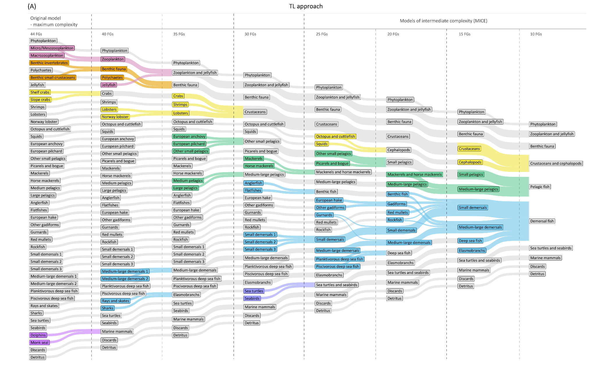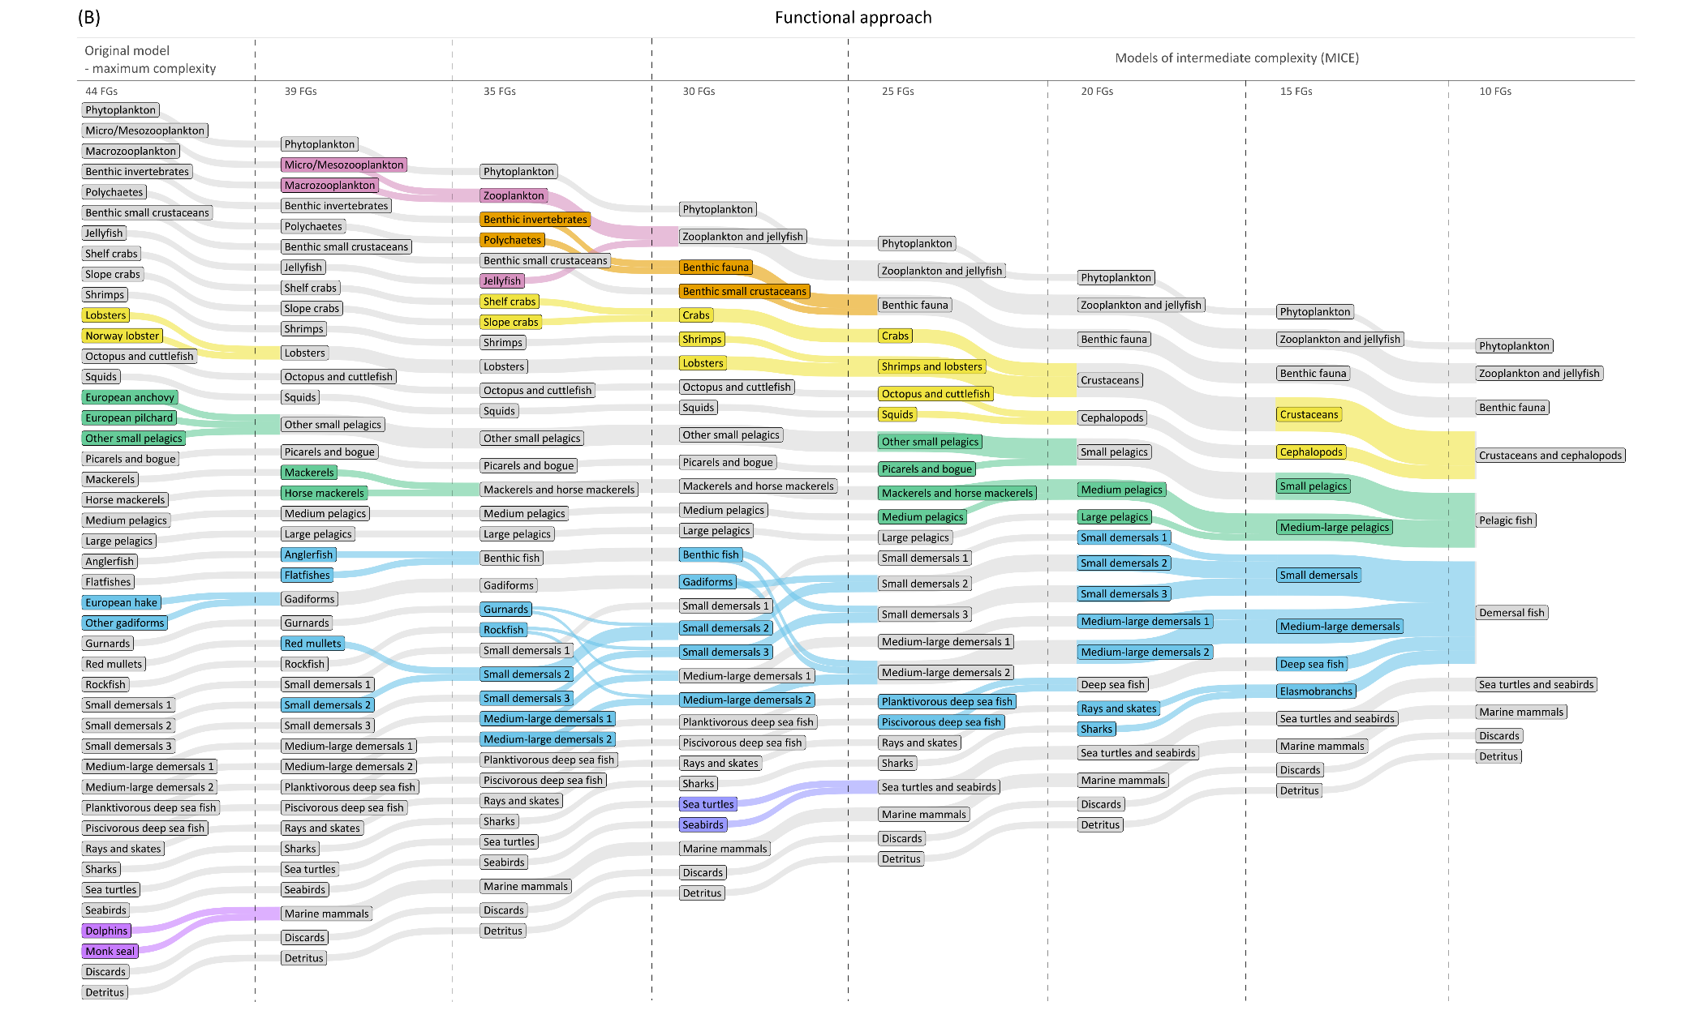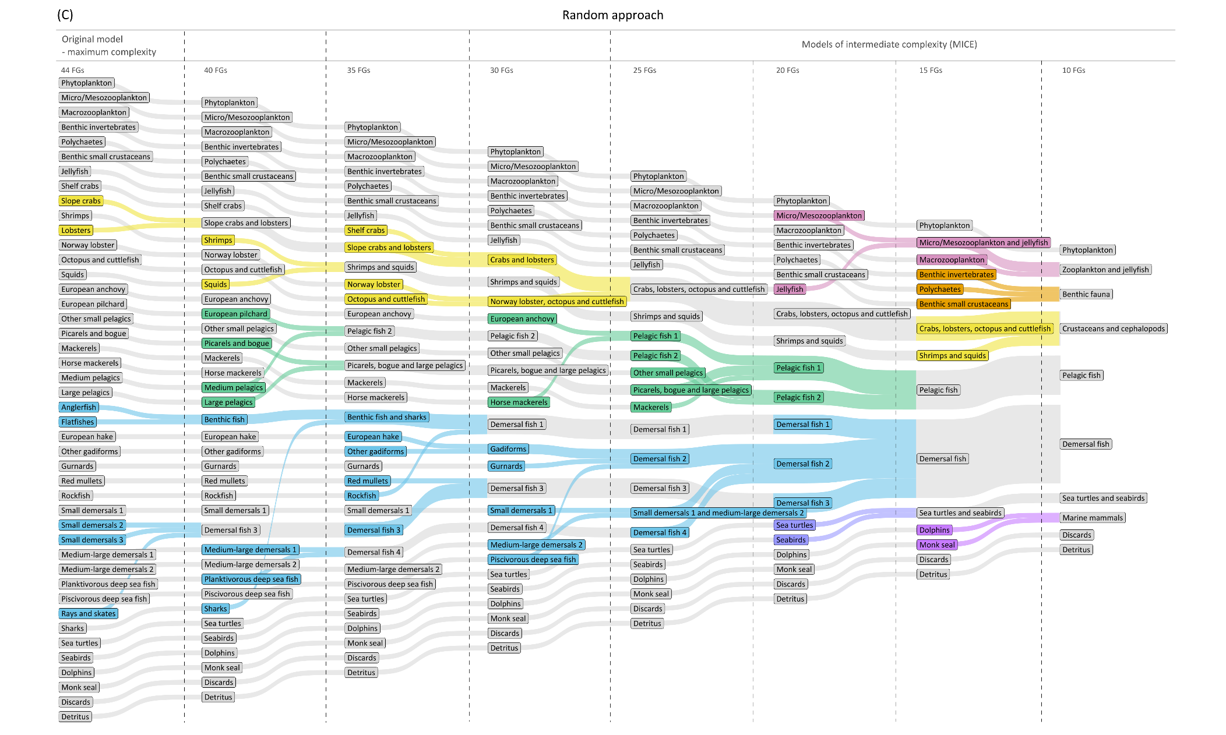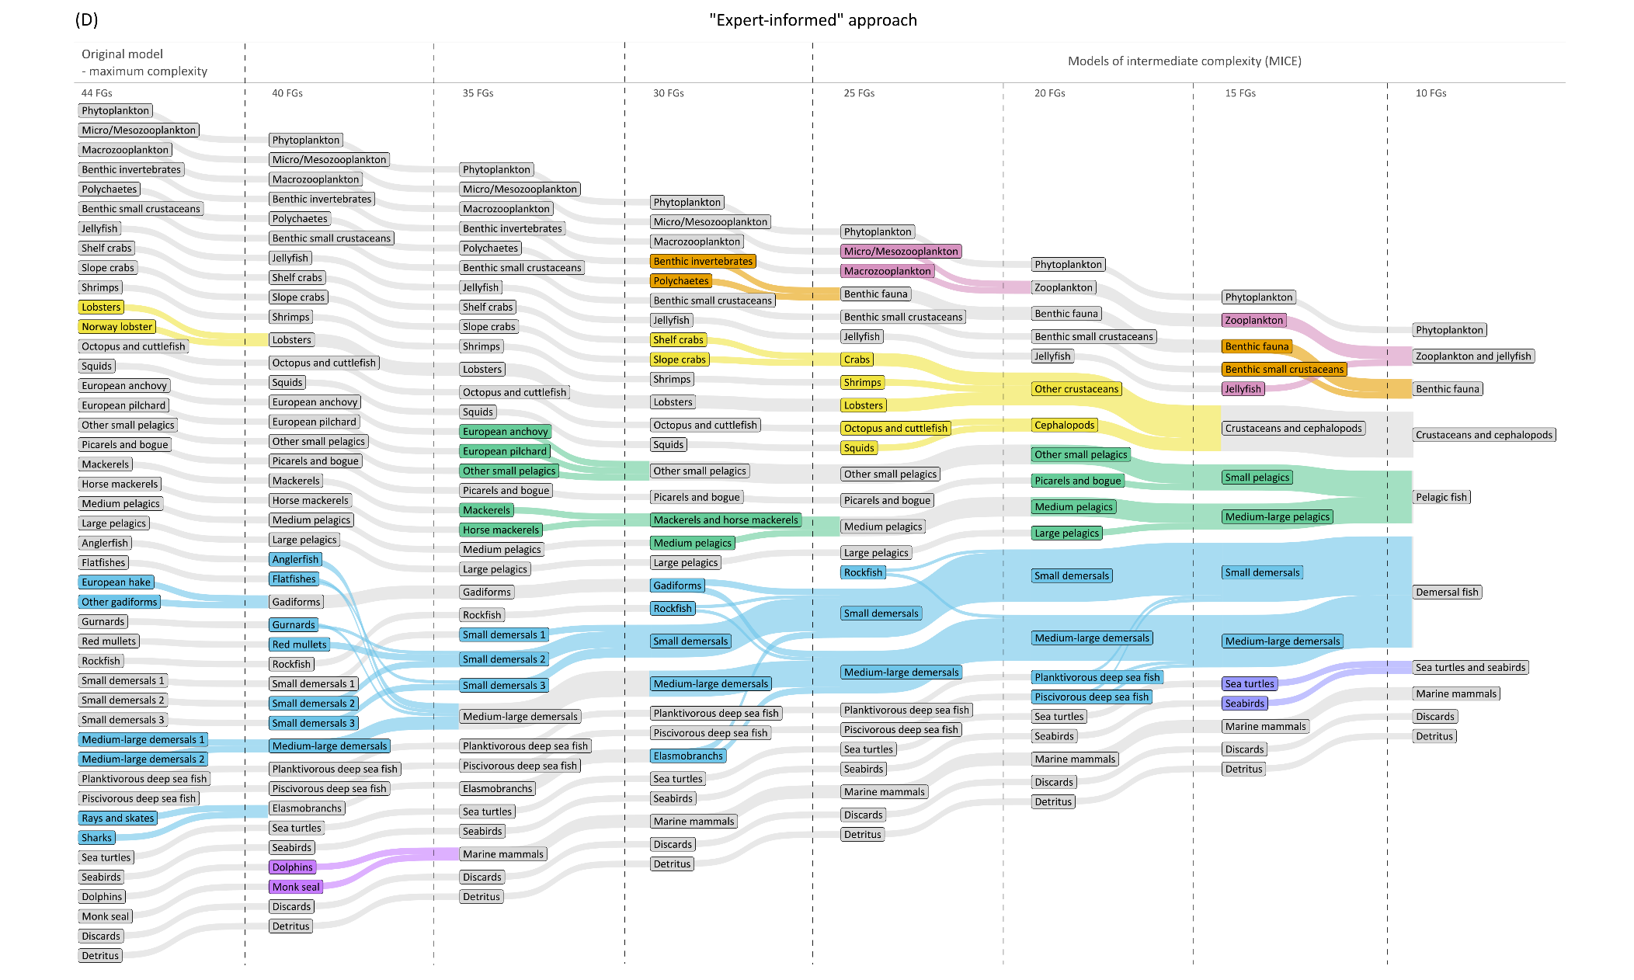
Figure 2. Flow diagrams showing the aggregation sequence between functional groups (FGs) in each model and complexity level (number of FGs) for (A) trophic level (TL), (B) functional, (C) random and (D) “expert-informed” approach. Flow width represents the number of aggregated FGs in each new FG and not their biomass. All aggregations that result in the same final FG are highlighted with the same flow color. Flows with grey color indicate that no aggregation took place and that these FGs remain the same at the next aggregation level.

2.2. PERFOMANCE EVALUATION FRAMEWORK OF AGGREGATED MODELS
The performance of the aggregated models was evaluated through different criteria, based on the values of several ecological indicators. EwE framework provides an output of summary statistics and ecological network analysis (ENA) (Guesnet et al. 2015), involving indicators that describe the functioning and structure of the modelled ecosystem. Many of these can provide useful insights to assess the ecosystem state or compare different models and ecosystems. Additionally, the ECOIND plug-in was used, which consists of a set of algorithms that use EwE results and provide estimates of ecological indicators (Coll & Steenbeek 2017). These indicators can be based on biomass, catch, TL, size or species data and can be applied to track ecological changes in time and space or inspect for differences between ecosystems.
A sensitivity analysis was implemented to investigate the impact of species aggregation to model output. This analysis was performed through structural modifications to the original Ecopath model of the Aegean Sea, that were described in the previous section. Model complexity was gradually reduced, starting from 44 FGs of the original model, to 40 (or 39), 35, 30, 25, 20, 15 and 10 FGs, by applying four different aggregation approaches (TL, functional, random, and “expert-informed”). Sensitivity to species aggregation was assessed through different criteria examining the magnitude and direction of changes in indicator values, across the different approaches and the multiple aggregation levels in each approach, that would help to select the most suitable model as the MICE. The following subsections describe the main components of this evaluation framework: (i) description of the studied ecological indicators, (ii) the performance criteria for the MICE selection procedure.

2.2.1. ECOLOGICAL INDICATORS USED FOR SPECIES AGGREGATION IMPACT
The indicators used to study the impact of gradually reducing model complexity on model performance, were separated into ecosystem and trophic indicators (Table 1). These indicators provide a useful basis to evaluate changes in the structural and trophic properties of simplified models. The ecosystem indicators used were Total System Throughput (TST), ascendency, relative ascendency (% ascendency), relative overhead (% overhead), relative redundancy (% redundancy), Finn’s Cycling Index (FCI), Shannon index and Primary Production Required to sustain fisheries to Total Primary Production (PPR/TotPP). The trophic indicators used were System Omnivory Index (SOI), mean Trophic Level of the catch (mTLc), Marine Trophic Index (MTI) and Trophic Level of the community (TLco).
Table 1. Ecosystem and trophic indicators estimated with the Ecopath software and the ECOIND plug-in, along with their description. The calculation method of each indicator can be found in Heymans et al. (2014).
Indicator category | Indicator | Description
Ecosystem | Total System Throughput  (TST, t km⁻² year⁻¹) | Represents the sum of all flows in the system (= total consumption + total export + total respiration + total flows to detritus) or else the size of the entire system referring to flow (Ulanowicz 1986).
Ecosystem | Ascendency (flowbits) | Measures the average mutual information in a system, scaled by the system throughput (Ulanowicz & Norden 1990) and refers to the size and organization of the system (Ulanowicz 1986).
Ecosystem | Relative ascendency (% ascendency) | Represents the ascendency divided by the capacity of the system (Ulanowicz 1986).
Ecosystem | Relative overhead (% overhead) | Expresses the difference between the capacity and the ascendency divided by the capacity of the system (Ulanowicz 1986).
Ecosystem | Relative redundancy (% redundancy) | Represents the overhead on internal flows divided by the capacity of the system (Ulanowicz & Norden 1990).
Ecosystem | Finn’s Cycling Index (FCI) | Quantifies the fraction of an ecosystem's throughput that is recycled (Finn 1976).
Ecosystem | Shannon diversity index | Quantifies how evenly the biomass is distributed across the functional groups of the system (Shannon 1948, Christensen & Walters 2024).
Ecosystem | Primary Production Required / Total Primary Production (PPR/TotPP) | Expresses the proportion of primary production of the system that is necessary to sustain fisheries (Christensen & Pauly 1993).
Trophic | System Omnivory Index (SOI) | Expresses the average omnivory index (variance of the trophic level of a consumer's prey groups) of all consumers weighted by the logarithm of each consumer's food intake (Pauly et al. 1993, Christensen & Walters 2004).
Trophic | Mean Trophic Level of the catch (mTLc) | Expresses the position of the species caught by fisheries in the food web and indicates the fishing impact on ecosystem trophic structure (Pauly et al. 1998).
Trophic | Marine Trophic Index (MTI) | Represents the trophic level of the catch including organisms with trophic level greater than or equal to 3.25 (Pauly & Watson 2005).
Trophic | Trophic level of the community (TLco) | Represents the mean trophic level of the community including all organisms (Heymans et al. 2014).

2.2.2. PERFORMANCE EVALUATION CRITERIA
Three different criteria were used to evaluate the performance of each aggregated model and aggregation approach, in order to result in a MICE model. The value thresholds for the criteria were defined before the evaluation of the model results, based on expert judgement and the objective of maintaining balance between original model ecological features preservation and model simplification.
The first criterion is linked to the proportion of indicators showing an absolute change of ≤10% between two successive aggregation levels in each aggregation approach. For each indicator $k$ and aggregation level $l$, the successive relative change $S_{k,l}$ was calculated as:
$$S_{k,l}= \left|\frac{X_{k,l}- X_{k,l-1}}{X_{k,l-1}}\right|×100$$
where $X_{k,l}$ represents the value of indicator $k$ at aggregation level $l$, while $X_{k,l-1}$ represents its value in the next aggregation level. The successive relative change was calculated separately for each indicator. The percentage (%) of indicators with an $S_{k,l}$≤ 10% was then calculated for each aggregation level and approach. A higher percentage indicated that a greater number of indicators showed a relatively small change across aggregation levels, whereas a lower percentage suggested that aggregation resulted in more extensive changes in model outputs. The 10% threshold was defined based on expert judgment, as it was considered to represent relatively small successive changes in indicator values. This level of magnitude has also been applied in the methodology of different ecological studies to distinguish relatively minor deviations from changes that are ecologically meaningful (Prato et al. 2014, Whitehouse & Aydin 2020).
The second criterion was based on the proportion of indicator values that remained within the uncertainty bounds estimated to account for the parameter uncertainty of model input data. These uncertainty bounds were obtained by using the Monte Carlo routine (Metropolis & Ulam 1949, Kavanagh et al. 2004) implemented in the original Ecosim model (Keramidas et al. 2024). The routine was run until 100 parameter sets of input data produced a balanced Ecopath model. The resulting ranges of indicator values were recorded and used to estimate a 90% confidence interval for each indicator. For each aggregated model $m$, the proportion of indicator values falling within these uncertainty bounds $T_{m}$ was calculated as:
$$T_{m}= \frac{N_{within, m}}{I} ×100$$
where $N_{within, m }$ represents the number of indicator values from aggregated model $m$ that fell within the corresponding 90% confidence intervals estimated from the Monte Carlo simulations, and $I$ is the total number of indicators. A value of 50% or higher was considered desirable. This threshold was accepted as a minimum acceptable limit to retain consistency with the uncertainty range, while possibly allowing to reduce model complexity substantially.
Finally, model performance was evaluated by calculating the mean percentage difference between the indicator values obtained from each aggregated model and those of the original model. For each model $m$, this difference $D_{m}$ was calculated as:
$$D_{m}= \frac{1}{I} \sum_{k=1}^{I}{\left|\frac{x_{mk}-x_{0k}}{x_{0k}}\right| ×100}$$
where $x_{mk}$ represents the value of indicator $k$ in the aggregated model $m$, $x_{0k}$ is the corresponding value in the original model, and $I$ is the total number of indicators. Ideally, this difference was required to remain below or equal to 10% to identify relatively small average deviation from the original indicator values, and to be consistent with the threshold used for the successive relative change of indicator values. Although some of the indicators are mathematically or ecologically related, each one represents a different aspect of ecosystem structure and functioning. The purpose was to assess how aggregation affected a range of established and commonly used indicators, rather than providing a statistically independent index.

2.3.1. INDICATOR VALUES
The ecosystem indicators TST, relative ascendency, relative overhead and relative redundancy, were robust compared to the original model across all aggregation levels and approaches, representing a mean relative difference of their values under 5% (Figure 3 & 4). TST and relative overhead showed stable value trends, while the trends of relative ascendency and redundancy were generally stable, with specific exceptions that occurred, for relative ascendency at 30 FGs of the functional approach and at 15 FGs of the random approach, and for relative redundancy at 15 FGs of the random approach. Under the random approach, relative ascendency reached its lowest value at 15 FGs and then increased at 10 FGs, while relative redundancy reached its highest value at 15 FGs and then decreased at 10 FGs. Aggregation influenced the ascendency, FCI and Shannon indicators across all aggregation approaches and at most aggregation levels (Figures 3 & 4). Ascendency and Shannon values decreased while FCI generally increased as the number of FGs was reduced. However, the aggregation level and the magnitude of the changes varied across the different aggregation approaches. Specifically, FCI and Shannon were two of the most sensitive indicators among all examined indicators, within and beyond the ecosystem category. The indicator PPR/TotPP presented strong variation, mostly with declining values as the number of FGs was reduced in each approach. PPR/TotPP was the most sensitive indicator, across all indicator categories and aggregation approaches. In general, the random approach was the least influenced approach by aggregations, across all ecosystem indicators, until the aggregation level of 15 FGs (Figures 3 & 4).
All aggregation approaches influenced the SOI indicator in most aggregation levels (Figures 3 & 4). SOI showed fluctuations in its values, rather than a consistent directional trend. MTI and mTLc indicators remained stable in all aggregation levels and approaches (Figures 3 & 4). MTI presented a moderate negative difference in its values, compared to the original model, only at 10 FGs. The most robust indicator was TLco, with its values remaining essentially stable among all aggregation levels and approaches.
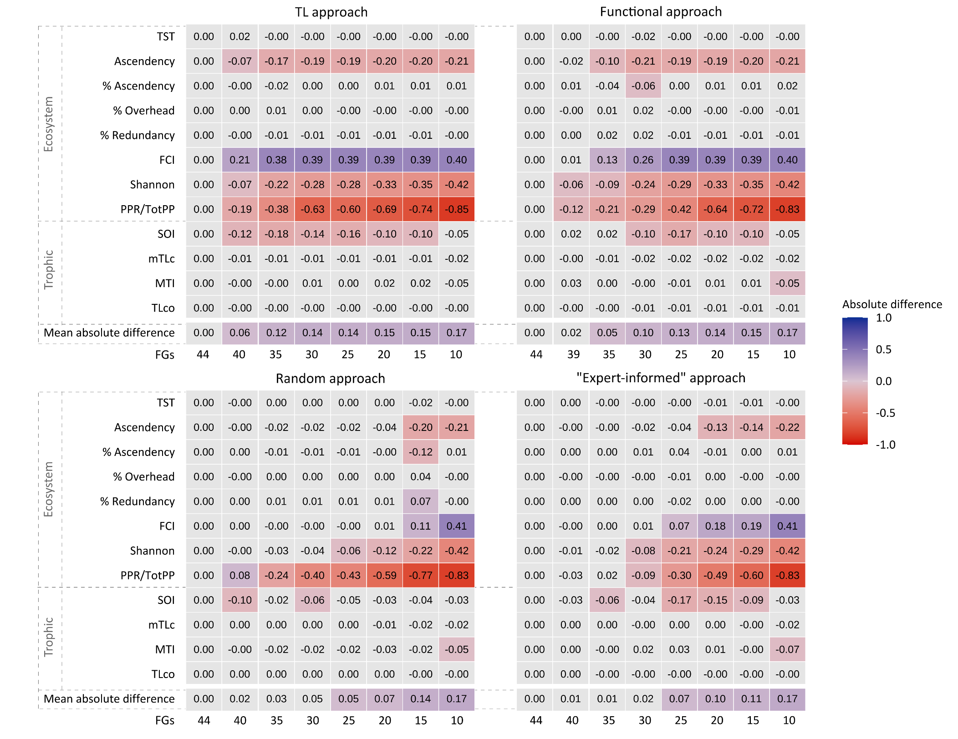
Figure 3. Heatmap representing the absolute difference in ecosystem and trophic indicators (see Table 1 for definitions) of the aggregated models (different number of functional groups-FGs) developed with each aggregation approach (trophic level-TL, functional, random and “expert-informed”), compared to the original Ecopath model of the Aegean Sea (44 FGs). The mean difference across all indicators combined is also shown. Grey boxes indicate minor differences (between -0.05 and 0.05), blue boxes indicate considerable positive differences (≥ 0.05), and red boxes indicate considerable negative differences (≤-0.05). Most intense color shades highlight the largest deviations from the original model. Values were rounded to two decimal digits.
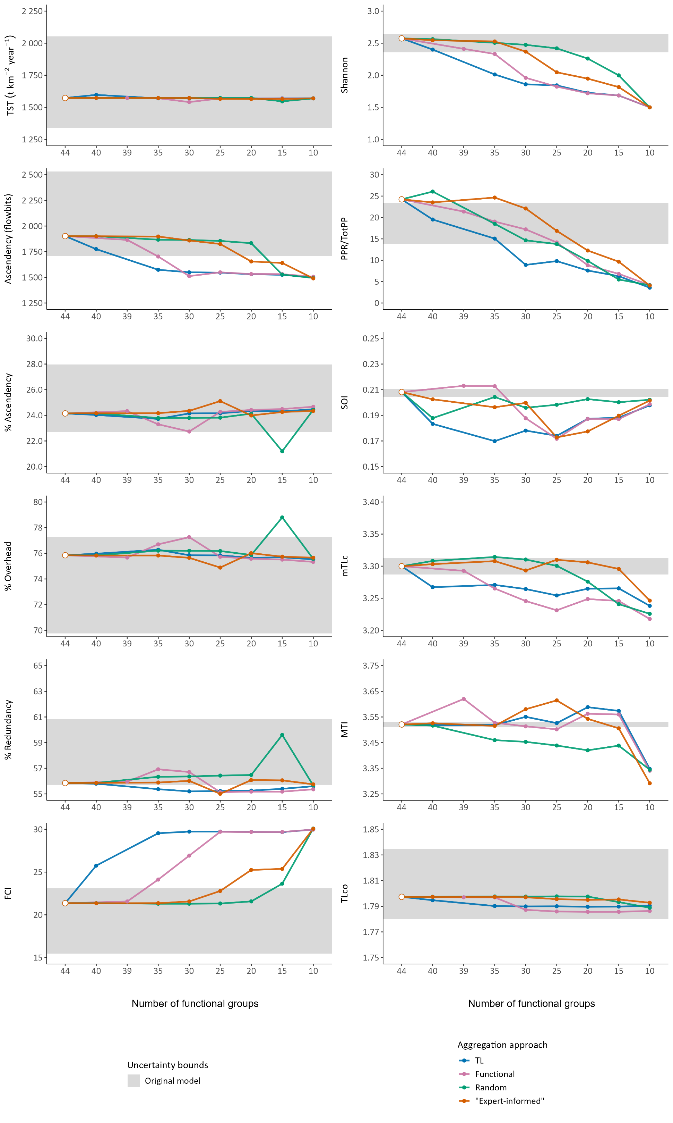
Figure 4. Sensitivity plots of the estimated indicator values (consult Table 1 for definitions) across the different aggregation approaches and number of functional groups (FGs), starting from the original Ecopath model of the Aegean Sea (44 FGs). Blue lines represent values from the aggregated models developed with the TL approach, pink lines stand for the functional approach, green lines for the random approach and orange lines for the “expert-informed” approach. Grey areas define the uncertainty bounds (90% confidence interval) derived from the Monte Carlo routine. The white point in each plot signifies indicator values from the original Ecopath model.

2.3.2. PERFORMANCE EVALUATION
The proportion of indicators that presented an absolute change of ≤10% between two successive aggregation levels was calculated for each aggregation level of each approach (Table 2). Between 44-40 and 40-35 FGs, the TL approach had the lowest percentage of indicators showing successive relative change ≤10%, with values of 75% and 66.7%, respectively. However, these percentages increased considerably at subsequent aggregation levels, reaching 91.7-100% between 30-15 FGs, while declining to 83.3% at the final aggregation level of 10 FGs. During the initial aggregations, the functional approach showed a higher proportion of indicators within the desired threshold, recording 91.7% between 44-39 FGs and 83.3% between 39-35 FGs. Subsequently, the lowest value of 66.7% was observed for the functional approach between 35-30 FGs, while an increase to 83.3-91.7% occurred across the remaining aggregations. A more consistent pattern was observed for the random approach, with repeatedly high percentages of 91.7-100% from 44 to 20 FGs. However, the percentage of indicators remaining within the 10% threshold decreased to 66.7% at aggregations between 20-15 and 15-10 FGs. Between 44-40 and 40-35 FGs, the “expert-informed” approach presented all of its indicators (100%) with a successive relative change ≤10%. The percentage remained high between 35-30 FGs, with a value of 91.7%, while decreasing to 75% and 83.3% between 30-25 and 25-20 FGs, respectively. The percentage increased to 91.7% at the aggregation between 20-15 FGs, before decreasing to 75% at the last aggregation between 15-10 FGs.
The proportion of indicators that fell within the range of the uncertainty bounds (90% confidence intervals) decreased as the number of FGs was reduced (Table 2). The requirement that at least 50% of indicator values should remain within the uncertainty bounds was met only down to the aggregation level of 35 FGs for the TL approach and of 30 FGs for the functional approach. In comparison, the random and “expert-informed” approaches sustained this condition down to the aggregation level of 20 and 15 FGs, respectively.
The absolute mean difference of indicator values of each aggregated model from the original model increased in all aggregation approaches, as complexity was reduced (Figure 4 & Table 2). Less than half of the models (12/28, 43%) produced indicator values that did not exceed the desired threshold of 10% difference, in comparison to the original model values. The TL and functional approaches remained within the threshold only at the first and the second aggregation level, respectively. The “expert-informed” approach fulfilled this criterion down to 25 FGs and the random approach down to 20 FGs.
Table 2. Performance criteria developed for evaluating the performance of each aggregation approach (trophic level-TL, functional, random, “expert-informed”) and aggregated model (different number of functional groups-FGs), to select a Model of Intermediate Complexity (MICE) for the Aegean Sea ecosystem. For the first criterion, the successive relative change threshold was set below or equal to 10%. For the second criterion, the threshold regarding the percentage of indicator values that fell within the ranges of uncertainty bounds calculated by different parameter sets of input data for the original model, was set above or equal to 50%. For the third criterion, the mean percentage difference between the original and the aggregated models was required to remain below or equal to 10%. Models with desired values for the second and third criteria are presented above the dashed line.
Criterion: the successive relative change threshold <= 10% | Approach | Number of FGs | % indicators fulfilling criterion
Criterion: the successive relative change threshold <= 10% | “Expert-informed” | 40 | 100.0
Criterion: the successive relative change threshold <= 10% | “Expert-informed” | 35 | 100.0
Criterion: the successive relative change threshold <= 10% | “Expert-informed” | 30 | 91.7
Criterion: the successive relative change threshold <= 10% | “Expert-informed” | 25 | 75.0
Criterion: the successive relative change threshold <= 10% | “Expert-informed” | 20 | 83.3
Criterion: the successive relative change threshold <= 10% | “Expert-informed” | 15 | 91.7
Criterion: the successive relative change threshold <= 10% | “Expert-informed” | 10 | 75.0
Criterion: the successive relative change threshold <= 10% | Functional | 39 | 91.7
Criterion: the successive relative change threshold <= 10% | Functional | 35 | 83.3
Criterion: the successive relative change threshold <= 10% | Functional | 30 | 66.7
Criterion: the successive relative change threshold <= 10% | Functional | 25 | 83.3
Criterion: the successive relative change threshold <= 10% | Functional | 20 | 91.7
Criterion: the successive relative change threshold <= 10% | Functional | 15 | 91.7
Criterion: the successive relative change threshold <= 10% | Functional | 10 | 83.3
Criterion: the successive relative change threshold <= 10% | Random | 40 | 100.0
Criterion: the successive relative change threshold <= 10% | Random | 35 | 91.7
Criterion: the successive relative change threshold <= 10% | Random | 30 | 91.7
Criterion: the successive relative change threshold <= 10% | Random | 25 | 100.0
Criterion: the successive relative change threshold <= 10% | Random | 20 | 91.7
Criterion: the successive relative change threshold <= 10% | Random | 15 | 66.7
Criterion: the successive relative change threshold <= 10% | Random | 10 | 66.7
Criterion: the successive relative change threshold <= 10% | TL | 40 | 75.0
Criterion: the successive relative change threshold <= 10% | TL | 35 | 66.7
Criterion: the successive relative change threshold <= 10% | TL | 30 | 91.7
Criterion: the successive relative change threshold <= 10% | TL | 25 | 100.0
Criterion: the successive relative change threshold <= 10% | TL | 20 | 91.7
Criterion: the successive relative change threshold <= 10% | TL | 15 | 91.7
Criterion: the successive relative change threshold <= 10% | TL | 10 | 83.3
Criterion: inside the range of uncertainty bounds | Approach | Number of FGs | % indicators fulfilling criterion
Criterion: inside the range of uncertainty bounds | Random | 40 | 83.3
Criterion: inside the range of uncertainty bounds | “Expert-informed” | 40 | 83.3
Criterion: inside the range of uncertainty bounds | Functional | 39 | 83.3
Criterion: inside the range of uncertainty bounds | “Expert-informed” | 35 | 83.3
Criterion: inside the range of uncertainty bounds | Random | 30 | 83.3
Criterion: inside the range of uncertainty bounds | “Expert-informed” | 30 | 83.3
Criterion: inside the range of uncertainty bounds | TL | 40 | 75.0
Criterion: inside the range of uncertainty bounds | Random | 35 | 75.0
Criterion: inside the range of uncertainty bounds | Random | 25 | 75.0
Criterion: inside the range of uncertainty bounds | “Expert-informed” | 25 | 66.7
Criterion: inside the range of uncertainty bounds | Functional | 35 | 58.3
Criterion: inside the range of uncertainty bounds | Functional | 30 | 58.3
Criterion: inside the range of uncertainty bounds | Random | 20 | 58.3
Criterion: inside the range of uncertainty bounds | TL | 35 | 50.0
Criterion: inside the range of uncertainty bounds | “Expert-informed” | 20 | 50.0
Criterion: inside the range of uncertainty bounds | “Expert-informed” | 15 | 50.0
Criterion: inside the range of uncertainty bounds | TL | 25 | 41.7
Criterion: inside the range of uncertainty bounds | Functional | 25 | 41.7
Criterion: inside the range of uncertainty bounds | “Expert-informed” | 10 | 41.7
Criterion: inside the range of uncertainty bounds | TL | 30 | 33.3
Criterion: inside the range of uncertainty bounds | Functional | 20 | 33.3
Criterion: inside the range of uncertainty bounds | TL | 20 | 33.3
Criterion: inside the range of uncertainty bounds | Functional | 15 | 33.3
Criterion: inside the range of uncertainty bounds | TL | 15 | 33.3
Criterion: inside the range of uncertainty bounds | Functional | 10 | 33.3
Criterion: inside the range of uncertainty bounds | Random | 10 | 33.3
Criterion: inside the range of uncertainty bounds | TL | 10 | 33.3
Criterion: inside the range of uncertainty bounds | Random | 15 | 25.0
Criterion: mean difference between the original and the aggregated models | Approach | Number of FGs | Value
 | “Expert-informed” | 40 | 0.6
 | “Expert-informed” | 35 | 0.8
 | Random | 40 | 1.5
 | Functional | 39 | 2.3
 | “Expert-informed” | 30 | 2.3
 | Random | 35 | 2.9
 | Random | 30 | 4.7
 | Random | 25 | 5.2
 | Functional | 35 | 5.4
 | TL | 40 | 5.7
 | Random | 20 | 7.0
 | “Expert-informed” | 25 | 7.4
 | Functional | 30 | 10.2
 | “Expert-informed” | 20 | 10.2
 | “Expert-informed” | 15 | 11.1
 | TL | 35 | 11.5
 | Functional | 25 | 12.6
 | Random | 15 | 13.6
 | TL | 25 | 13.8
 | TL | 30 | 13.9
 | Functional | 20 | 14.3
 | TL | 20 | 14.7
 | Functional | 15 | 15.2
 | TL | 15 | 15.2
 | Random | 10 | 16.6
 | “Expert-informed” | 10 | 16.7
 | Functional | 10 | 16.9
 | TL | 10 | 16.9

2.3.3. MICE MODEL SELECTION
None of the aggregation approaches presented a steady, monotonic decline in the proportion of indicators meeting the successive relative change threshold as the number of FGs reduced (Table 2). Nevertheless, the most stable declines with higher values of this proportion during the early and intermediate stages of aggregation was observed for the random and expert-informed approaches. Under the random approach, the values for both the uncertainty bounds criterion and the mean percentage difference criterion remained within the desired thresholds down to the aggregation level of 20 FGs. It is important to emphasize that the random approach is not entirely random, as the aggregation choices are guided by ecological and biological restrictions. Based on these results, the random model of 20 FGs provided the least complex model structure that fulfilled the required performance criteria and was consequently selected as the MICE model for the Aegean Sea ecosystem.

2.3. MICE EXECUTION WITHIN THE SURIMI MODELLING WORKFLOW
SURIMI’s toolbox consists of a set of open-source and interchangeable socio-ecological, assessment and policy models that will present how fishing activities and management options affect marine species, habitats, and biodiversity hotspots. The required data and models, depending on the case study considered (Northwestern Mediterranean, Aegean Sea, Anchovy Bay), will be provided through a visualization interface, including user-centric decision support tools. Work package 3 (WP3) is designed to develop and provide the selection of socio-ecological and management strategy evaluation (MSE) models for open-source use outside of SURIMI. SURIMI assessments, models and e-tools will be based on curated data freely accessible through the SURIMI data lake (WP2), considering fisheries, climate, biological, ecological and socio-economic information. Model inputs and outputs will be available through a graphical user interface, where the models will communicate (Figure 5), together with user-centric graphical tools for visualizing and analyzing SURIMI data (WP4). Within the SURIMI modelling framework, EwE models will be incorporated to represent the trophic structure and functioning of the ecosystems, as well as changes that occur under spatiotemporal simulations. MICE models will also be integrated to present the existing ecological models in a simplified structure, supporting the interoperability objective of SURIMI (Figure 6). Both EwE and MICE models will be connected to the DTO infrastructure, together with models targeting stock assessment, fisheries, socio-economics, and supply chain objectives.
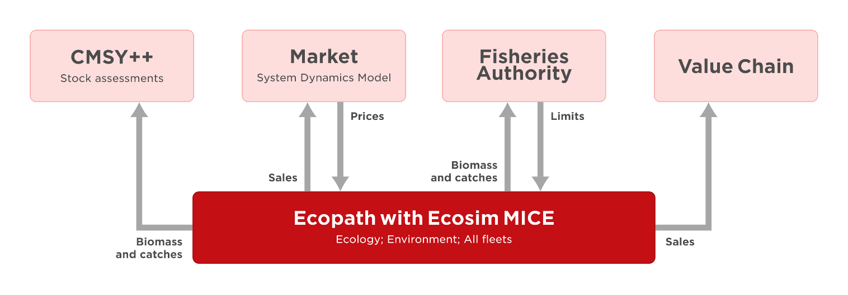
Figure 5. Model interactions and data exchanges between the SURIMI components involved in the Aegean case study within the SURIMI modelling framework.
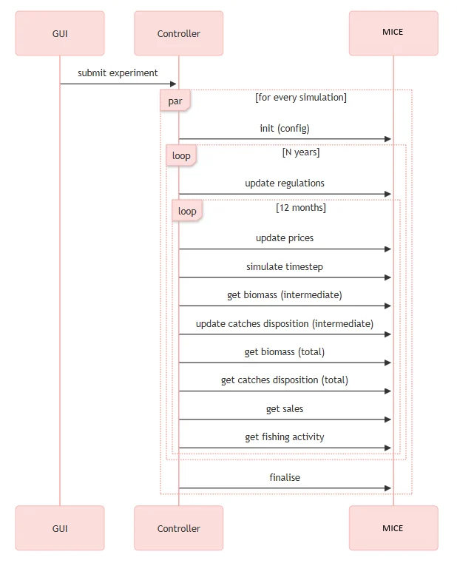
Figure 6. MICE execution within the SURIMI workflow, showing the order of exchanges of simulation data between the SURIMI Controller and the MICE.

3. INPUTS
The MICE model required estimates for biomass in the habitat area (t km⁻²), production/biomass ratio (P/B, year⁻¹), consumption/biomass ratio (Q/B, year⁻¹), and unassimilated consumption as basic input for each FG. Additionally, diet composition data were needed, as well as landings
(t km⁻² year⁻¹) and discards (t km⁻² year⁻¹) values for each FG caught by all fishing gears in the modelled area. Moreover, the traits of each species belonging to each FG had to be defined, including characteristics like the type of organism (algae, invertebrates, fish, etc.) and its contribution to the total biomass and catch of the FG. Values of the off-vessel landing prices can also be incorporated to be used for future projections.
For the temporal simulations, time series of biomass and catch data, relative fishing effort estimates, trophic interactions controlled with vulnerabilities among FGs, a multiplier to the production rate of phytoplankton calculated through spline points of the anomaly tool, annual time series of sea surface temperature (SST, °C), and also an environmental response function combining the effect of the preferred range of SST of the functional groups, with the annual time series of SST, were incorporated as input data.

4. OUTPUTS
The MICE model can produce a static snapshot of the ecosystem under study, representing its structure and functioning across a set of statistics (Figure 7A) and ecological indicators (Figure 7B) derived through the EwE software and the ECOIND plug-in. The indicator values can provide conclusions regarding the trophic structure, energy flows, maturity, resilience, ecological properties, keystone species or even the fisheries impact on the system. Output files containing the basic input and output parameters as well as key indices, regarding trophic level composition, ecotrophic efficiencies and mortality values, can also be provided.
Regarding the dynamic simulations, the basic outputs include biomass (Figure 8A) and catch estimates (Figure 8B) for each FG of the food web throughout the study period, based on the baseline conditions or alternative scenarios, such as fisheries management measures or environmental disturbances. Additionally, trends of different ecological indicators can be obtained for the same time period and scenarios.
(B)
(A)
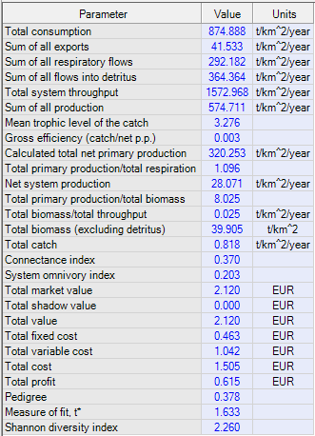 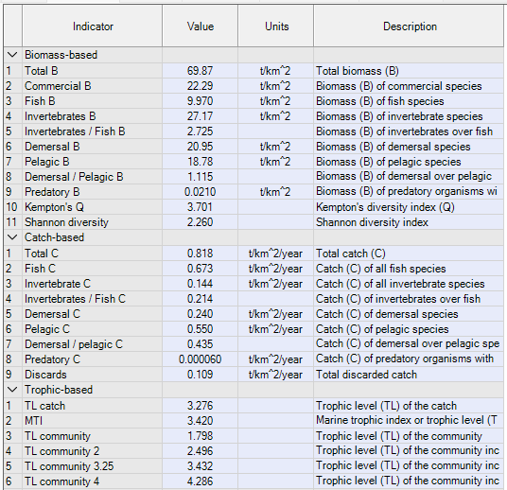
Figure 7. Indicative figure of MICE output generated through EwE software, showing A) summary statistics of the model and B) part of the ecological indicator values derived through the ECOIND plug-in.

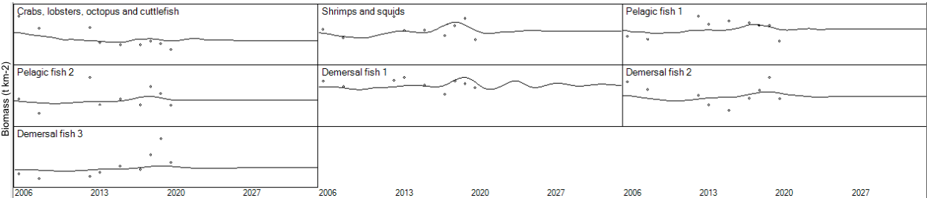
(A)
(B)
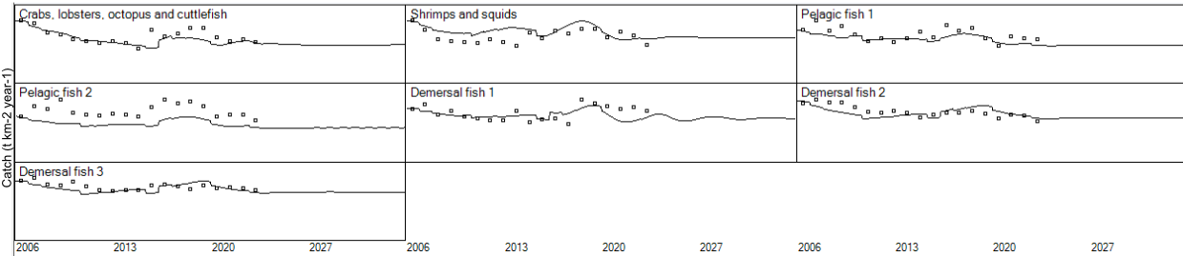
Figure 8. Available (A) biomass and (B) catch estimates for the MICE base model FGs of the Aegean Sea food web.

5. REFERENCES
Ahrens RNM, Walters CJ, Christensen V (2012) Foraging arena theory. Fish and fisheries, 13(1): 41-59.
Christensen V, Pauly D (1993) Flow characteristics of aquatic ecosystems. In: Christensen V, Pauly D (Eds.) Trophic Models of Aquatic Ecosystems. ICLARM Conference Proceedings 26, Manila, 338-352.
Christensen V, Walters CJ (2004) Ecopath with Ecosim: methods, capabilities and limitations. Ecological modelling, 172(2-4): 109-139.
Christensen V, Walters CJ (2024) Ecosystem modelling with EwE. The University of British Columbia. Vancouver, BC. 438 pp.
Coll M, Steenbeek J (2017) Standardized ecological indicators to assess aquatic food webs: The ECOIND software plug-in for Ecopath with Ecosim models. Environmental Modelling & Software, 89: 120-130.
Drew K, Cieri M, Schueller AM, Buchheister A, Chagaris D, Nesslage G, McNamee JE, Uphoff Jr JH (2021) Balancing model complexity, data requirements, and management objectives in developing ecological reference points for Atlantic menhaden. Frontiers in Marine Science, 8: 608059.
Finn JT (1976) Measures of ecosystem structure and function derived from analysis of flows. Journal of theoretical Biology, 56(2): 363-380.
Fulton EA, Smith ADM, Johnson CR (2003) Effect of complexity on marine ecosystem models. Marine Ecology Progress Series, 253: 1-16.
Giricheva E (2015) Aggregation in ecosystem models and model stability. Progress in Oceanography, 134: 190-196.
Guesnet V, Lassalle G, Chaalali A, Kearney K, Saint-Béat B, Karimi B, Grami B, Tecchio S, Niquil N, Lobry J (2015) Incorporating food-web parameter uncertainty into Ecopath-derived ecological network indicators. Ecological Modelling, 313: 29-40.
Haller-Bull V, Rovenskaya E (2019) Optimizing functional groups in ecosystem models: Case study of the Great Barrier Reef. Ecological Modelling, 411: 108806.
Heymans JJ, Coll M, Libralato S, Morissette L, Christensen V (2014) Global patterns in ecological indicators of marine food webs: a modelling approach. PloS one, 9(4): e95845.
Heymans JJ, Coll M, Link JS, Mackinson S, Steenbeek J, Walters C, Christensen V (2016) Best practice in Ecopath with Ecosim food-web models for ecosystem-based management. Ecological modelling, 331: 173-184.
Johnson GA, Niquil N, Asmus H, Bacher C, Asmus R, Baird D (2009) The effects of aggregation on the performance of the inverse method and indicators of network analysis. Ecological Modelling, 220(23): 3448-3464.
Kavanagh P, Newlands N, Christensen V, Pauly D (2004) Automated parameter optimization for Ecopath ecosystem models. Ecological Modelling 172: 141-149.
Keramidas I, Dimarchopoulou D, Kokkos N, Sylaios G, Tsikliras AC (2024) Temporal ecotrophic impacts of fisheries and climate change in the Aegean Sea. Marine Ecology Progress Series, 749: 19-45.
Keramidas I, Dimarchopoulou D, Tsikliras AC (2022) Modelling and assessing the ecosystem of the Aegean Sea, a major hub of the eastern Mediterranean at the intersection of Europe and Asia. Regional Studies in Marine Science, 56: 102704.
Metropolis N, Ulam S (1949) The monte carlo method. Journal of the American statistical association, 44(247): 335-341.
Pauly D, Christensen V, Dalsgaard J, Froese R, Torres F (1998) Fishing down marine food webs. Science, 279(5352): 860-863.
Pauly D, Soriano-Bartz ML, Palomares MLD (1993) Improved construction, parametrization and interpretation of steady-state ecosystem models. In: Christensen V, Pauly D (Eds.), Trophic Models of Aquatic Ecosystems. ICLARM Conference Proceedings 26, Manila, 1-13.
Pauly D, Watson R (2005) Background and interpretation of the ‘Marine Trophic Index’ as a measure of biodiversity. Philosophical Transactions of the Royal Society B: Biological Sciences, 360(1454): 415-423.
Plagányi ÉE, Punt AE, Hillary R, Morello EB, Thébaud O, Hutton T, Pillans RD, Thorson JT, Fulton EA, Smith ADM, Smith F, Bayliss P, Haywood M, Lyne V, Rothlisberg PC (2014) Multispecies fisheries management and conservation: tactical applications using models of intermediate complexity. Fish and Fisheries, 15(1): 1-22.
Prato G, Gascuel D, Valls A, Francour P (2014) Balancing complexity and feasibility in Mediterranean coastal food-web models: uncertainty and constraints. Marine Ecology Progress Series, 512: 71-88.
Shannon CE (1948) A Mathematical Theory of Communication. The Bell System Technical Journal, 27: 379-423.
Ulanowicz RE (1986) Growth and Development: Ecosystem Phenomenology. Springer Verlag, New York. 203 pp.
Ulanowicz RE, Norden JS (1990) Symmetrical overhead in flow networks. International Journal of Systems Science, 21(2): 429-437.
Walters C, Christensen V, Pauly D (1997) Structuring dynamic models of exploited ecosystems from trophic mass-balance assessments. Reviews in fish biology and fisheries, 7(2): 139-172.
Whitehouse GA, Aydin KY (2020) Assessing the sensitivity of three Alaska marine food webs to perturbations: an example of Ecosim simulations using Rpath. Ecological Modelling, 429: 109074.

Scientific Coordinator
Patrycja Antosz | paan@norceresearch.no

Project Management
Catherine Lourdes Dy | PMO-SURIMI@norceresearch.no

Press and Communications
Keegan Porter | keegan@erinn.eu
Emma Bello Gomez | emma@erinn.eu

More Information
Website | surimi-project.eu
LinkedIn | SURIMI Project
Bluesky | @surimi-project.bsky.social

